Design and Manufacturing Ⅰ
Final report

2023-2024-2

Project title: Multifunctional Ball Collecting Vehicle

Group member: Aaron Dixon Drawing Lichen Millis

Class：Intelligent Manufacturing Engineering

Shien-Ming Wu School of Intelligent Engineering

June 2024

Abstract
This paper presents the design and development of a compact, multi-functional, and visually appealing pick-and-place robot for a range of balls, spanning from ping-pong balls to basketballs. The robot, designed to fit within a 50cm x 50cm x 50cm box, incorporates an innovative ball collection method utilizing collision dynamics, eliminating the need for complex mechanical grasping mechanisms. This approach not only simplifies the robot's structure but also enhances energy efficiency and control simplicity. The robot features an integrated body design that harmoniously blends aesthetics with functionality, including a high-performance 24V motor drive system, a refined suspension system for enhanced durability and comfort, and a user-friendly PS2 controller for flexible operation. Additionally, the robot is designed to withstand collisions during contests, ensuring durability and reliability. This paper discusses the robot's key features, highlights its performance capabilities, and outlines potential future improvements to further enhance its functionality and versatility.

Content
Abstract 2
1. Introduction 4
2. Concept Design 5
2.1 Problem Definition 5
2.2 Quality Function Deployment (QFD) 6
2.2.1 Customer Requirements (CRs) 7
2.2.2 Engineering Characteristics (ECs) 8
2.2.3 Relation Matrix 8
2.2.4 Importance Ranking 8
2.3 Foreseen problems 9
2.3.1 Budget constraints: 9
2.3.2 Improper material selection: 9
2.3.3 Motors Insufficient power: 9
2.3.4 Servos Insufficient accuracy: 9
3. Design 10
3.1 Method to collect the ball 10
3.2 Movement method 10
3.3 Material of the body 11
4. Manufacturing 12
4.1 Mechanical structure and appearance design 12
4.2 Materials and model selection 13
4.3 Model Design Process 15
4.4 Electronic control and component selection 20
4.5 Control program 21
5. Analysis of Our Car's Features and Highlights 22
6. Our Future Outlook for the Ball-Collecting Car Design 23
7. Cost Estimation 24
8. Conclusion 27
9. Acknowledgement 28
10. Reference 28
Appendix Ⅰ. All sketches in concept design 29
Appendix Ⅱ. All engineering draws with Solidworks 30
Appendix Ⅲ. Product Design Specifications 31
Appendix Ⅳ. Details of Prototyped machines 33

Introduction
In the realm of robotics, designing a compact yet highly efficient system for specific tasks has always been a challenge. Our group has tackled this challenge by developing a unique pick-and-place robot specifically tailored for handling a diverse range of balls, from lightweight ping-pong balls to heavier basketballs. This robot is not only expected to fulfill its primary function of efficiently collecting and placing balls into designated areas but also to do so within stringent size constraints, ensuring it fits within a 50cm x 50cm x 50cm box.
The design of this robot was driven by a multifaceted approach that balanced functional requirements with aesthetic considerations. Recognizing the need for durability and reliability in competitive environments, the robot was engineered to withstand collisions without compromising its performance. Furthermore, we aimed to create a visually appealing machine that would not only function effectively but also be visually pleasing, incorporating post-processing treatments such as polishing, painting, and decorative frames.
At the core of our design lies an innovative method for collecting balls, which leverages collision dynamics rather than traditional mechanical grasping mechanisms. This approach significantly simplifies the robot's structure, reducing complexity and energy consumption. By eliminating the need for additional mechanical arms and motors, we were able to streamline the robot's design and facilitate simpler circuit control programs. Moreover, this method demonstrates robustness, ensuring that balls of various diameters are consistently and reliably transported to their designated locations.
In this paper, we delve into the design philosophy, technical specifications, and performance capabilities of our pick-and-place robot. We highlight the robot's key features, including its integrated body design, high-performance motor drive system, refined suspension system, and user-friendly PS2 controller. Additionally, we discuss the challenges faced during the design and development process and offer insights into potential future improvements that could further enhance the robot's functionality and versatility. Our goal is to present a comprehensive overview of our robot's design and capabilities, showcasing its potential as a highly efficient and visually appealing solution for ball pick-and-place tasks, and finally win the final competition.

Concept Design

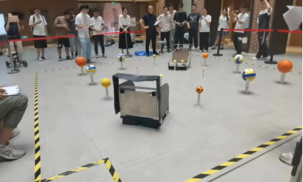
Problem Definition
(Figure1.The contest scene)
The proposed robot must be compact enough to fit within a 50cm x 50cm x 50cm box. Its primary function is to grasp the ball from the column in the scene, load them in the basket, transport, and place a variety of balls of different diameters in to appointed area, from ping-pong ball to basketball. To ensure durability and reliability in contests, the robot must be designed to withstand a certain amount of collision. Additionally, aesthetic considerations are essential; the robot should undergo post-processing treatments such as polishing, painting, and the addition of decorative frames to enhance its visual appeal. The overall design should be both functional and visually pleasing, ensuring that it meets both operational and aesthetic standards.

Quality Function Deployment (QFD)
Given that QFD methodically translates customer requirements into actionable product features while ensuring that customer expectations and needs are meticulously addressed during the development process, we will employ this approach to thoroughly analyze and design our concept for a small car.
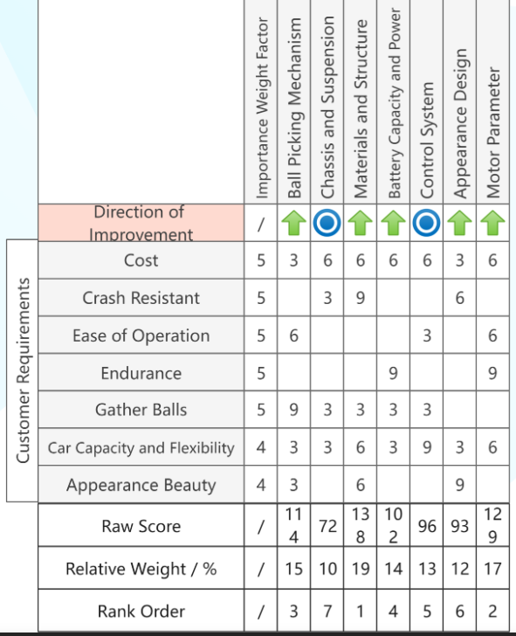
(Figure 2.QFD of the car we designed)

2.2.1 Customer Requirements (CRs)
①Cost: Need an affordable solution that offers good value for their money.
②Crash Resistance: Ensuring the car is durable and can withstand impacts is crucial for long-term usability, especially in environments where it might encounter obstacles.
③Ease of Operation: The small car must be easy to control.
④Endurance: The car should have a long battery life or fuel efficiency to perform gathering tasks for extended periods without needing frequent recharges or refueling.
⑤Gathering Balls: This is the primary function of the car, so it must be highly efficient and effective in collecting balls.
⑥Car Capacity and Flexibility: The ability to hold and transport a large number of balls and adapt to different terrains or environments increases the car's utility.
⑦Appearance Beauty: A visually appealing design enhances customer satisfaction and marketability.

2.2.2 Engineering Characteristics (ECs)
①Ball Picking Mechanism: It is imperative that the mechanism is robust and effective, capable of efficiently collecting balls. This ensures that the primary function of the small car, ball collection, is executed with maximum reliability and speed.
②Chassis and Suspension: The chassis and suspension system are fundamental components that provide the necessary stability and resilience for the small car.
③Materials and Structure: The use of high-quality materials ensures the vehicle can withstand impacts and endure prolonged usage.
④Battery Capacity and Power: A high-capacity battery is essential to provide extended operational periods, thereby minimizing the need for frequent recharging.
⑤Control System: This system must facilitate precise control over the ball-gathering functions.
⑥Appearance Design: A visually attractive design enhances customer satisfaction and marketability, fulfilling the requirement for appearance beauty.
⑦Motor Parameter: The motor parameter encompasses the specifications of the motor, including its power output and efficiency. The motor must be engineered to deliver sufficient power for the car to operate effectively while maintaining energy efficiency.

2.2.3 Relation Matrix
Next, we use the relation matrix to evaluate the correlation between customer requirements and engineering characteristics as in figure 3. For example, the customer requirement for gathering balls is strongly related to the ball picking mechanism, so we fill in 9 in the correlation matrix.

2.2.4 Importance Ranking
To prioritize our efforts, we have assigned an importance ranking to each customer requirement. This ranking is based on the relative significance of each requirement to our target customers. In details, we calculated the raw score of “Ball Picking Mechanism” using the function: .
We can get a conclusion from the rank order in figure 3 that the most critical aspects of project success are material and structure, motor parameter and ball picking mechanism. So in the next stage, we will focus on these aspects.

Foreseen problems

2.3.1 Budget constraints:
We may need to compromise on component choices, such as opting for less expensive but slightly weaker motors or main control boards.

2.3.2 Improper material selection:
Materials may be too heavy, affecting the robot's speed and flexibility; or the material may not be strong enough, leading to damage during collisions.

2.3.3 Motors Insufficient power:
The motors may not provide enough power to climb slopes or push heavy objects.

2.3.4 Servos Insufficient accuracy:
The accuracy of the servos may not meet the requirements for ball-picking precision.

We have proactively identified these potential challenges and have taken comprehensive measures to address them, ensuring the successful development of a robust and efficient ball-picking vehicle.

Design

Method to collect the ball
When we first saw the problem requirements, we thought that we could make a humanoid hand to grab the ball and then put the ball in the basket. However, after reading a few papers, we found that we can improve efficiency by using collision to pick up balls. This method not only simplifies the structure of our robot by eliminating the need for additional mechanical arms but also reduces energy consumption since no extra motors are required. Furthermore, it facilitates subsequent circuit control programs by obviating the need for a vision recognition module and the control of additional motors. This method also exhibits robustness; as long as the center of mass of the ball is positioned above the collision point and the ball collides with the support rod at an appropriate speed, the ball will enter the basket due to inertia.
The structure in figure 1 is a good choice to imitate.
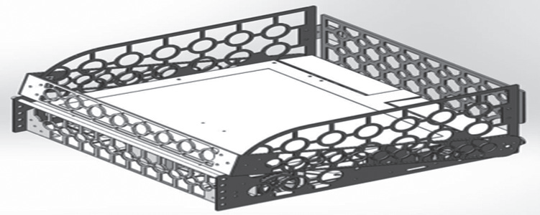
Figure 3.1.1 The car structure can be used for reference [1]

Movement method
Due to the competition requirements for lateral movement and on-the-spot turning, our robot utilizes Mecanum wheels for mobility. Although this method sacrifices some motor efficiency, it significantly improves control and mobility performance. It fully leverages the use of four motors for driving, eliminating the need for additional servos required for steering with conventional wheels.

Material of the body
The frame of the vehicle is constructed using an aluminum alloy to ensure its sturdiness. The side panels and the bottom plate are made of nylon material, which not only significantly reduces weight but also maintains a certain level of flexibility. This flexibility allows the vehicle to withstand collisions during competitions, effectively using softness to counteract rigidity. Nylon has high strength-to-weight ratio, which provides durability while keeping the vehicle lightweight. Compared to acrylic sheets, nylon is more flexible and less prone to cracking. When compared to cardboard, nylon offers superior strength and moisture resistance. Additionally, nylon outperforms iron sheets by being corrosion-resistant and significantly lighter, which contributes to better maneuverability and energy efficiency. Therefore, nylon is a better choice.
  - Suspension system
Due to the considerable weight of the entire vehicle and the placement of precise circuit control boards and batteries on the bottom plate, combined with the inherent characteristics of the Mecanum wheels causing vertical oscillations during movement, a suspension system is essential. Therefore, we designed a suspension system using hinges and springs to attenuate the oscillations of the wheels. This system ensures that the bumps are effectively absorbed by the springs, enhancing the vehicle's stability and performance.

Manufacturing

Mechanical structure and appearance design
Based on historical experiences and personal insights, we conceived a method to collect balls by colliding with the poles, causing the balls to fall into the vehicle's internal storage space due to inertia. The storage and transfer of the balls are facilitated by a rear-opening gate and a deployable barrier that prevents the balls from leaving the designated boundary.
To enhance the stability and practicality of the vehicle during operation, we have incorporated several optional features: a central opening to allow the poles to pass through the middle of the vehicle to prevent obstruction during subsequent collisions, a suspension system to stabilize the vehicle and reduce vibrations, and an effort to minimize the vehicle's size to improve its overall performance. While we successfully implemented the first two features, we decided to forego the third to ensure better overall functionality.
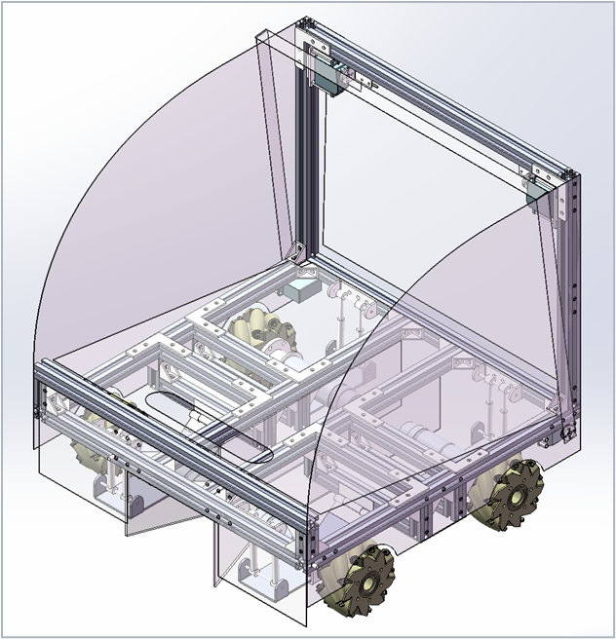
Figure 4.1.1 Right Isometric View of our Model
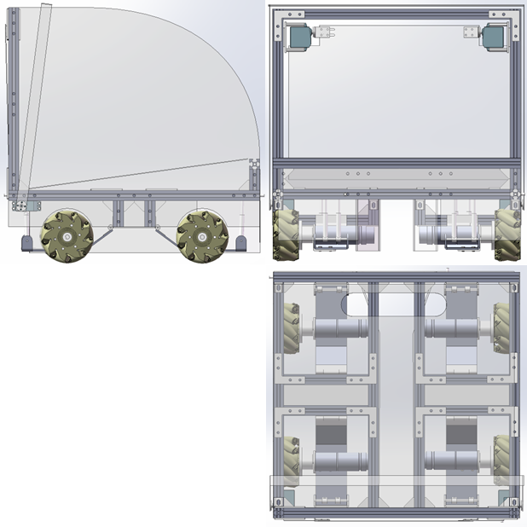
Figure 4.1.2 Three-View Drawing of our Model

Materials and model selection
In terms of material and component selection, we considered four key factors: weight and resilience, speed and load-bearing capacity, control, and additional features.
Weight and Resilience
We needed to decide on the material for the vehicle's body. While we had already decided on an aluminum frame, the material for the surface panels was still under consideration.
We initially considered using acrylic panels due to their reasonable price and hardness. However, acrylic's poor resilience posed a high risk of cracking under the high-impact environment and vibrations of the vehicle. Which is why we turned to Aluminium Alloy and Nylon. Aluminum Alloy addressed the resilience issue but added significant weight. Nylon panels offered good resilience but were relatively soft.
For our Final Decision, we chose to use nylon for the side panels, front panel, and the sliding panel of the vehicle, while the rear panel, which serves as the ball gate, was made from aluminum alloy.
Planetary Gear Motor with Hall Encoder
We selected a planetary gear motor with a reduction ratio of 1:51 due to its ability to handle high loads and increase torque, which is essential for our vehicle's performance. The integrated encoder is crucial for obtaining real-time speed feedback, allowing for precise PID control via PWM adjustments.
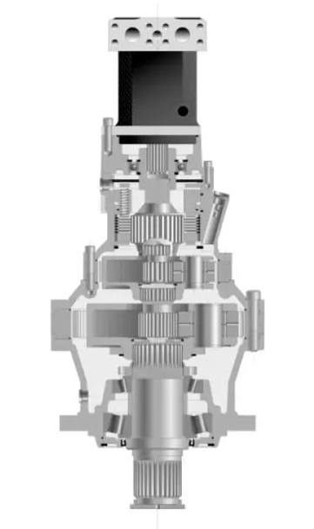
Figure 4.2.1 Planetary Gear Motor
Digital Servo Motor
A 20 kg-rated digital servo motor was chosen to ensure reliable operation regardless of the materials used for the rear panel and the ball containment framework. This servo provides the necessary torque and precision for our design requirements.
Mecanum Wheels
We chose Mecanum wheels due to their high maneuverability, which allows for turning and multi-directional movement using only four motors. This significantly simplifies the control system while enhancing the vehicle's agility.
Suspension System
We selected shock absorbers rated for 1-10 kg, the lightest available, considering that the overall weight of the vehicle would not exceed 10 kg. This choice was aimed at ensuring optimal stability and minimizing vibrations during operation.

Model Design Process
To meet the current requirements, we divide the robot into the following modules for modeling:
- Chassis: Provides mobility and the basic framework.
- Pickup Mechanism: Collects balls through impact, requiring internal height difference and sufficient storage space.
- Suspension System: Reduces vibration of various parts of the machine body, enhancing operational stability.
- Ball Release Mechanism: Releases the balls from the storage space from the rear and ensures they stay within the scoring area.
After understanding the requirements, we proceed to model each part of the robot, determining their physical characteristics and geometric structure.
4.3.1 Chassis Modeling
The chassis is the foundation of the entire robot structure and needs to be strong and stable enough to support the entire robot system. We need a sufficiently sturdy chassis frame to support subsequent mechanical structures, and given the strict 50x50x50 cm size requirement for our robot, our best choice is a square-structured chassis with a central column for support and stability.
The chassis material needs to be lightweight yet strong. We concluded that using aluminum profiles for the chassis construction is optimal. This material is easy to process, facilitating the construction of various structures. We initially modeled the robot's chassis in SolidWorks:
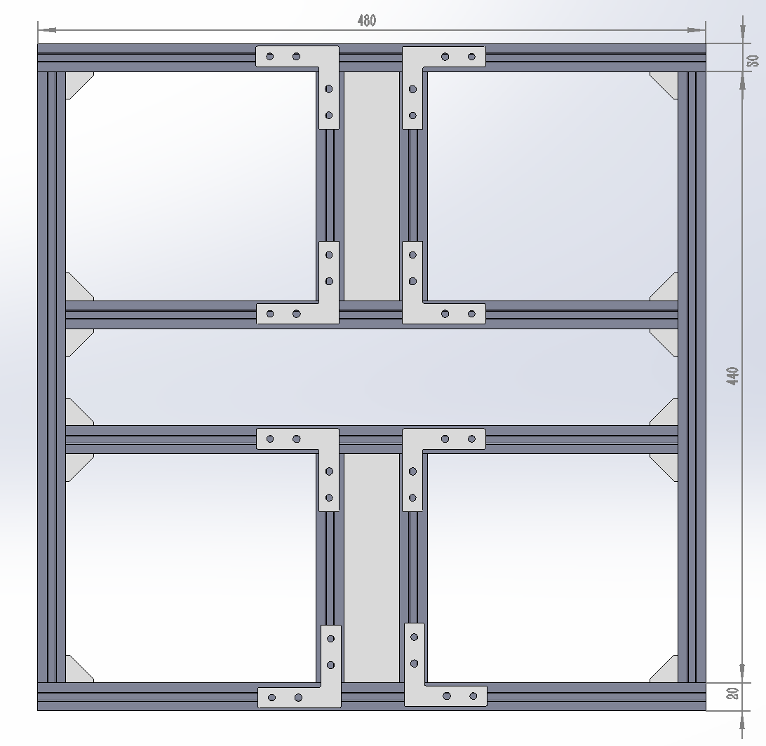
Figure 4.3.1.1 Upper View of Classis
Its dimensions are slightly smaller than 50 cm, considering potential shell wall thickness and screw thickness.
4.3.2 Pickup Mechanism
The pickup mechanism collects balls through impact, and its design needs to consider the height difference and storage space. It must address the following points:
- Height Difference: Design an inclined guide plate, low at the front and high at the back, to use gravity to roll the balls into the storage space.
- Storage Space: Design a sufficiently large storage space above the chassis, constructed with side walls, to store the collected balls.
- Pickup Mechanism: Reserve an impact position at the front for the height of the ball, allowing the robot to knock the ball onto the guide plate when moving forward.
Based on these requirements, we proceed with modeling:
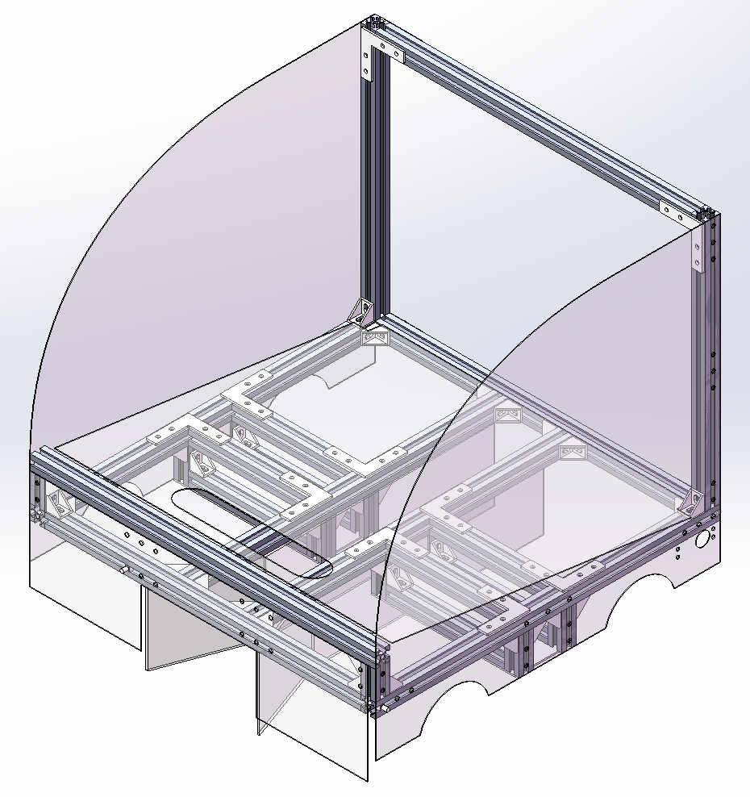
Figure 4.3.2.1 Right Isometric View of the Classis with Pickup Mechanism
4.3.3 Suspension System Modeling
The suspension system is used to reduce body vibration and ensure stable operation. We decided to design an independent suspension system, with each wheel having an independent suspension unit, enhancing its passability and stability:
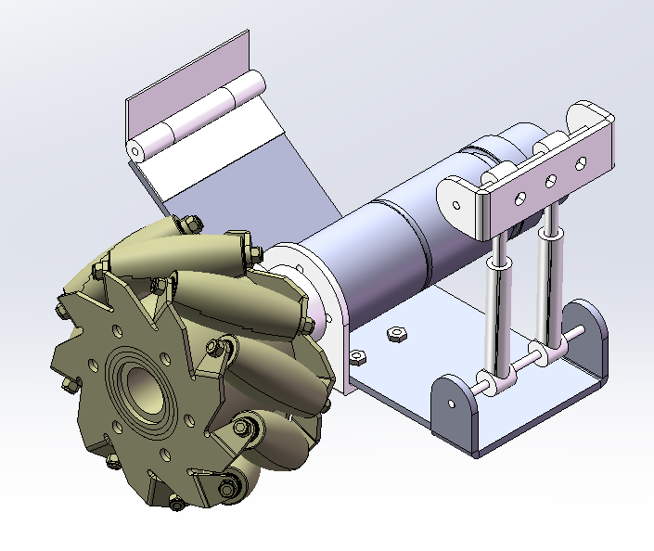
Figure 4.3.3.1 Isometric View of of the Suspension System
Finally, the suspension system is mounted on the chassis, as shown below:
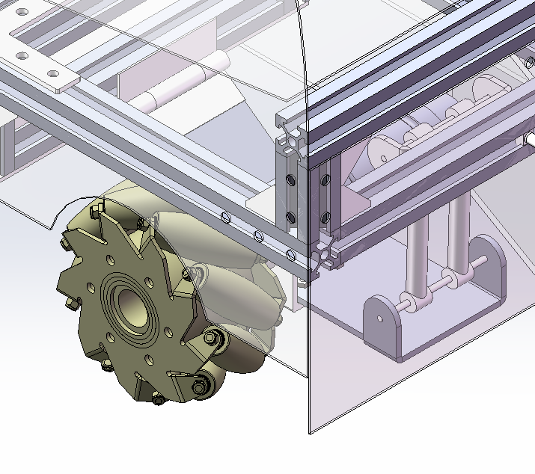
Figure 4.3.3.2 Isometric View of the Suspension System applied to the Classis
4.3.4 Ball Release Mechanism
The ball release mechanism needs to release the balls from the storage space at the rear and ensure they stay within the scoring area. Therefore, we install a control gate at the rear of the storage space, controlled by a motor to open and close. When the control gate is opened, the balls in the storage space slide out by gravity, ensuring the balls fall smoothly into the scoring area.
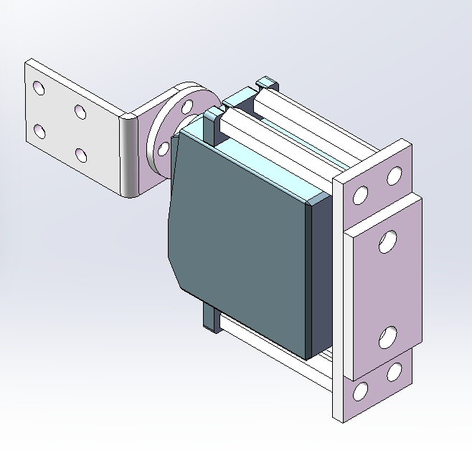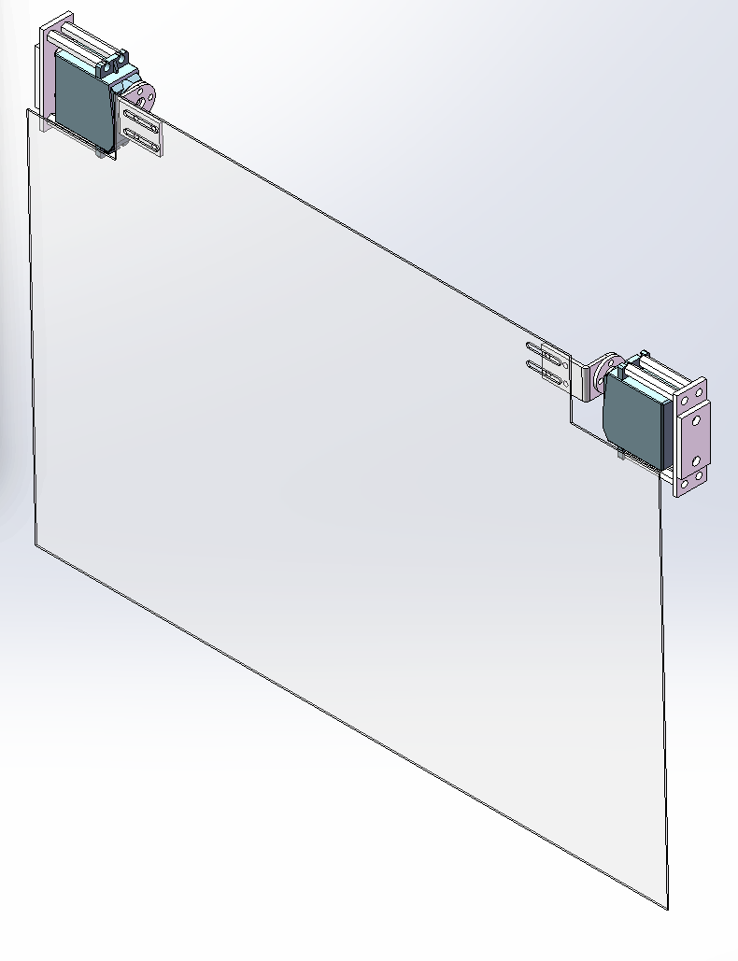
Figure 4.3.4.1 Isometric View of the Control Gate
To ensure the balls stay within the scoring area after release, we added a blocking system below the chassis. This blocking system limits the balls in the placement area and can be retracted to the upper part of the machine body when not in use, compressing storage space:
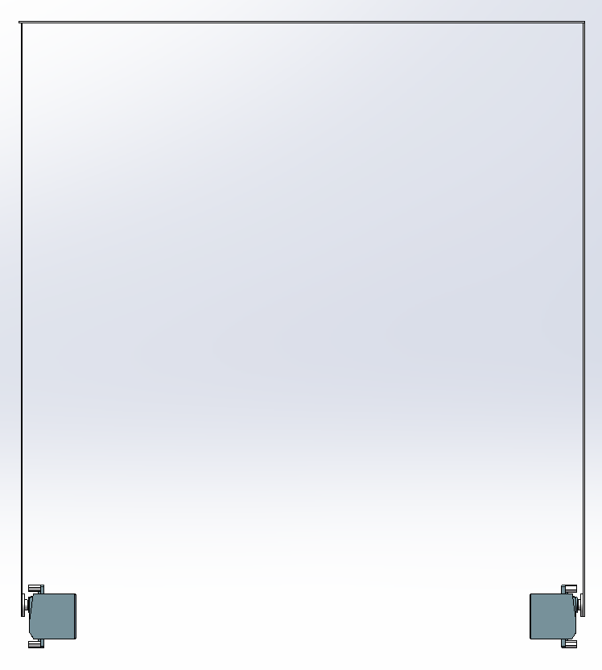
Figure 4.3.4.1 Upper View of the Blocking System
Finally, the blocking system is added to the previously constructed body, resulting in the final effect as shown below:
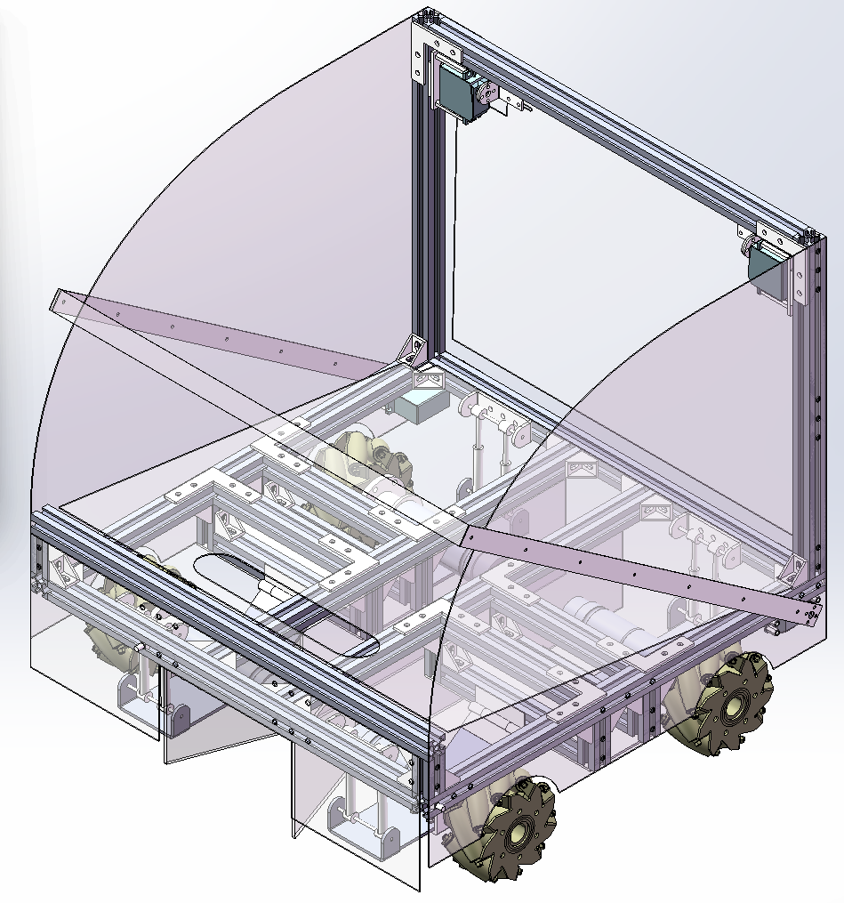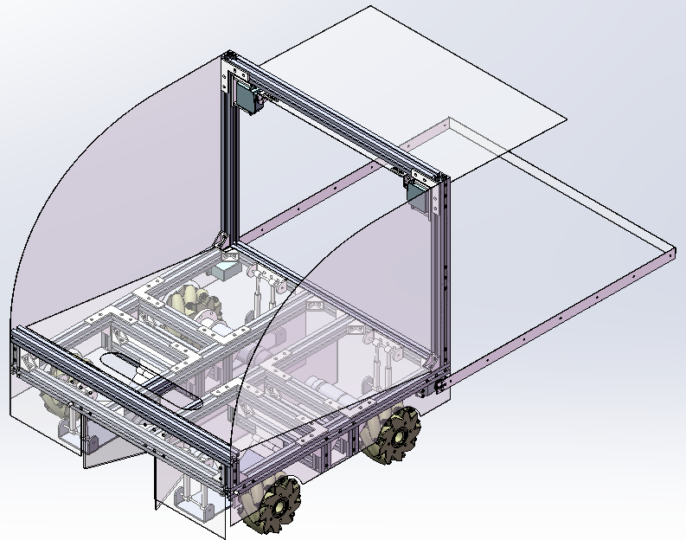
Figure 4.3.4.2 Storage Mode and Operating Mode of the Model

Electronic control and component selection
In the layout of the control system, the main control chip can choose STM32-f407VET6 single chip microcomputer. Because this type of single-chip microcomputer has low energy consumption, and has a relatively fast processor and memory, it is more suitable for dealing with complex control systems.[2] For instance, compared to alternatives such as Arduino, the STM32 offers more advanced features and better scalability for larger projects. Considering multiple advantages of STM32, we chose it as the electronic control board of the car.
We chose the C50C as the core control board. It features four encoder motor interfaces, reserved PS2 signal input, dual motor control board interfaces, and multiple servo interfaces. Additionally, it is equipped with a balance sensor. The rich functionality and numerous interfaces of the C50C greatly meet our requirements.
The PS2 controller offers high compatibility with various platforms and devices, making it easy to interface with different systems. It also provides proven stability and reliability, having been tested in the market for years. Therefore, we selected the PS2 as our remote control.
We selected DC brushed gear motor with a reduction ratio of 1:51. This high-torque motor effectively supports the weight of our vehicle and delivers power output at a high rotational speed, ensuring efficient performance. The motor's design allows it to fully harness the power output of our battery, providing the necessary torque and speed for optimal operation. Its robust construction and efficiency make it ideal for handling the demands of our multifunctional intelligent car.
We selected a digital servo with a torque of 20kg and a rotation range of 270 degrees, which fully meets our requirements. By using PWM signals to control it, we can achieve very high precision. Additionally, the servo operates at a sufficient speed to meet our needs, ensuring both accuracy and responsiveness in its performance.

Control program
The program consists of two parts—initialization and the main program. The main body of the main program is motion control, which is the most important part of the main program.
First, we declare and initialize all necessary hardware pin variables, such as ADC pins to read voltage, encoder pins to return motor information, and PWM pins for motors and steering servos.
In the main program, we continuously send and assign tasks to the single board according to the clock cycle.
In motion control, we begin by reading control signals from the PS2 controller. These signals are analog signals from the joystick—used to control the motion motors, and signals from buttons—used to control the servos—combined. These signals will be stored in global variables and processed in later parts of the program.
For the motors, the controller inputs an analog signal, which is calculated to be the target speed of the motor. By comparing the target speed with actual speed information returned by the encoder, the program will be able to calculate the appropriate PWM signal for the motors through PID and output the signal to the motor control board.
The formula is as follows: pwm += Kp[e(k)-e(k-1)] + Ki*e(k)
Where Kp, Ki are hyperparameters, e(n) is the difference between the target speed and actual speed of the motor at the moment n.
In the smooth control function, we simply ignore input changes below a threshold, and get VXYZ values to calculate the target speed. This formula is determined by the Mecanum wheel.
After calculation, we limit the target PWM value to avoid hardware failure.
For the servo, the controller's input includes the digital signals of the buttons, which are directly called in the program to make judgments. If triggered, they control the PWM signal of the servo and allow it to rotate to a specific angle.

Analysis of Our Car's Features and Highlights
In delving into the core elements of our project, our meticulously designed ball-collecting car stands out with its unique innovations and practicality, serving as the cornerstone of our success. The following is a detailed analysis of the car's primary features and highlights, aimed at elucidating its technical prowess and exceptional user experience.
5.1 Integrated Body Design: Aesthetic and Functional Harmony
Foremost among the car's highlights is its integrated body design, which imparts a sleek and aerodynamic appearance. The deep black finish accentuates a powerful and cohesive look, while the ingenious integration of the power switch directly into the body not only simplifies operation but also enhances the overall aesthetics, showcasing a seamless blend of technology and aesthetics.
5.2 High-Performance 24V Motor Drive System
To ensure the car's efficiency and stability during missions, we have adopted an advanced 24V motor as its power source. With its formidable output power and impressive torque, this motor empowers the car to carry multiple balls simultaneously and achieve high speeds, laying a solid foundation for its superior performance. This choice underscores our forward-thinking approach to technology selection and underscores our confidence in the car's capability to complete tasks efficiently.
5.3 Refined Suspension System: Comfort and Durability
To further optimize the car's ride quality and longevity, we have equipped it with a highly precise suspension system. Utilizing springs as shock absorbers, this system effectively dampens vibrations, reduces noise levels, and minimizes friction and wear, ultimately enhancing energy efficiency. This innovative design not only elevates the car's ride comfort but also significantly enhances its stability and reliability over extended periods, providing users with a more reassuring experience.
5.4 PS2 Controller: Flexibility and Convenience in Control
To achieve precise adjustments and personalization of the car's performance, we have incorporated a PS2 controller into the control system. With its intuitive layout and ergonomic design, the controller allows users to effortlessly adjust the car's speed, acceleration, and other critical parameters in real-time. This feature enhances the car's adaptability to different venues and requirements, ensuring maximum flexibility and convenience for users.
In conclusion, our car excels in its body design, motor configuration, suspension system, and control mechanism, showcasing distinctive features and advantages. The cumulative effect of these highlights elevates the car's overall performance and user experience, firmly establishing the foundation for the project's successful implementation.

Our Future Outlook for the Ball-Collecting Car Design
As we look ahead to the future development of our ball-collecting car, we have clearly outlined three core areas of improvement aimed at enhancing the car's performance, user experience, and intelligence level.
First, Material Innovation and Structural Optimization. We are dedicated to advancing both material science and structural design to achieve higher durability and performance. Our journey has already seen significant progress, from basic materials like cardboard and plastic to transparent acrylic plates and now the aluminum-magnesium alloy we currently employ. In the future, we will further upgrade and iterate the entire body skeleton, striving to achieve a lighter overall vehicle weight without compromising structural strength, thereby achieving the perfect balance between lightweight and robustness.
Second, Programming Optimization and Enhanced User-Friendliness. We will delve deeper into optimizing the car's control program, placing the user at the center of our design to create an even more intuitive and convenient operating experience. Through continuous testing and adjustment, we will explore and set optimal control parameters, selecting the best PWM (Pulse Width Modulation) function values to refine the car's acceleration and deceleration behaviors, making it more agile and easy to maneuver.
Third, Intelligence Upgrade and Integration of Vision Recognition Module. Lastly, we plan to deeply integrate intelligent technologies into the car's design, particularly by incorporating a vision recognition module that will enable the car to proactively sense its surroundings and make decisions accordingly. This module will endow the car with the capability to automatically identify ball targets in its environment, adjust its posture and driving path in real-time, and ultimately realize functions such as automatic recognition, automatic route planning, and automatic ball picking. This innovation represents a significant leap forward in terms of enhancing the car's efficiency, automation level, and marking a crucial milestone towards full-fledged intelligence, revolutionizing the ball-collecting domain.

Cost Estimation
In the process of constructing the ball-picking vehicle, a detailed cost estimation was conducted to ensure the project stayed within budget while achieving the desired functionality and performance. The total cost of materials and components was meticulously documented and can be summarized as follows:
Table 1 Cost statistics
Classification | Details | Cost | Total cost
Materials | Nylon | ￥160 | ￥773.63
Materials | Sheet metal parts | ￥180 | ￥773.63
Materials | Aluminium profile | ￥73 | ￥773.63
Materials | Shock absorbers | ￥223.76 | ￥773.63
Materials | Other materials | ￥136.87 | ￥773.63
Electric control | Brush electrode plate | ￥699 | ￥1006
Electric control | Switch | ￥49 | ￥1006
Electric control | Brushed motor driver module | ￥258 | ￥1006
Driver module | Batteries | ￥318 | ￥1621.8
Driver module | Steering engines | ￥272 | ￥1621.8
Driver module | Mecanum wheels | ￥448 | ￥1621.8
Driver module | Motors | ￥552 | ￥1621.8
Driver module | Cables | ￥31.8 | ￥1621.8
￥3401.43

In constructing the ball-picking vehicle, our costs slightly exceeded the initial budget, culminating in a total expenditure of ￥3401.43 compared to the projected ￥3000. However, these additional costs have resulted in significant benefits and value that far surpass initial expectations as follows:
- Improved Quality and Durability
- High-Quality Materials: The choice of premium materials such as nylon, sheet metal parts, and aluminium profile has not only enhanced the structural strength of the vehicle but also increased its durability, thereby extending its operational lifespan.
- Shock Absorbers: The inclusion of shock absorbers ensures smooth operation over various terrains, reducing wear and tear on other components.
- Enhanced Performance and Functionality
- Electric Control Components: Utilizing high-quality brush electrode plates, switches, and brushed motor driver modules has resulted in a more stable and reliable electrical system, reducing the failure rate and increasing operational efficiency.
- Mecanum Wheels and Motors: High-performance Mecanum wheels and motors enable the vehicle to move flexibly, adapting to various operational needs and significantly improving efficiency and versatility.
- Strengthened Power and Control
- Batteries and Steering Engines: High-capacity batteries and efficient steering engines ensure that the vehicle possesses strong power and precise directional control, enabling prolonged and effective operation.
- Cables and Other Electrical Components: High-quality cables and other electrical components ensure the reliability of the vehicle’s electrical system, reducing maintenance costs and downtime.
- Long-Term Cost Reduction
Although the initial investment is slightly higher, the use of high-quality materials and components effectively reduces potential repair and replacement costs during the vehicle’s use. The efficient and stable performance also boosts productivity, thereby lowering overall costs in the long run.

Conclusion
Specifically, the compact and highly efficient pick-and-place robot developed by our team has demonstrated remarkable advantages and unique innovations in multiple aspects.
Firstly, in terms of functionality, the robot has successfully accomplished the task of picking up and placing balls of various sizes and weights within an extremely small space (50cm x 50cm x 50cm). This achievement not only reflects our proficiency in mechanical design and dynamics control but also showcases our precise understanding of the task requirements. By adopting an innovative collision dynamics-based collection mechanism, we have effectively eliminated the complexity and high energy consumption associated with traditional robotic arms, resulting in a more streamlined and efficient system.
Secondly, in terms of durability and reliability, we have placed particular emphasis on the robot's performance in competitive environments. Through carefully selected materials and structural design, the robot is able to maintain stable performance even when subjected to collisions, which is crucial for long-term operation in practical scenarios. Additionally, we have conducted rigorous testing and iterative optimization to ensure that the robot performs consistently well under various conditions.

Furthermore, from an aesthetic and user experience perspective, we have paid close attention to the robot's appearance and user interface. Post-processing treatments such as polishing and painting have enhanced the robot's sleek and appealing appearance, while the user-friendly PS2 controller has significantly reduced the difficulty of operation, making it accessible even to non-professionals.
Looking ahead, we plan to further explore and optimize the robot's performance based on the successful experience of this project. For instance, we could consider introducing more advanced sensor technology to improve the accuracy and speed of ball recognition, or optimize the control algorithms for smoother and more precise motion control. These improvements will further enhance the robot's overall performance and broaden its range of applications.
In conclusion, our pick-and-place robot has achieved significant results in design, functionality, durability, aesthetics, and user experience. We believe that this robot will not only play a vital role in specific task scenarios but also provide valuable insights and inspiration for future advancements in robotic technology.

Acknowledgement
Here, We sincerely thank Professor Zhang Yingjie and Teacher Xu Jing for their invaluable theoretical guidance and selfless assistance throughout the process of our car-making project. Additionally, We would like to express my gratitude to every member of our team. It is through our collective efforts and cooperation that this project has been successfully completed. Furthermore, We deeply appreciate the advice and help offered by all friends involved in the project. This experience has been extremely enriching for us, and we will always cherish it in my heart.

Reference
[1] Chen, X., Ouyang, W., Huang, L., Lai, H., Chen, X., & Li, D. (2020). Structural Scheme Analysis and Design of Ball Pickup Robot Based on Guangdong-Hong Kong-Macao Engineering Training. Modern Manufacturing Technology and Equipment, 5, 34-38.
[2] Wang, X. Y., Deng, X. Y., Ke, Y., & Wang, X. (2024). Design of intelligent lawn mower robot control system based on STM32. Electronic Technology University of Chengdu, Department of Intelligent Manufacturing Engineering, Chengdu, Sichuan, 611731.

Appendix Ⅰ. All sketches in concept design

Appendix Ⅱ. All engineering draws with Solidworks

Appendix Ⅲ. Product Design Specifications
Product Design Specifications for the Compact Ball Handling Robot
1. Product Overview and Problem Definition
1.1 Problem Definition
The proposed compact ball handling robot is designed to address the specific challenge of efficiently grasping, transporting, and placing a wide range of balls (from ping-pong to basketball size) within a highly constrained environment. The robot must fit within a 50cm x 50cm x 50cm box, ensuring its compactness and portability. Its primary objectives are:
To grasp balls from a designated column within the scene and load them into a basket.
To transport and accurately place these balls of varying diameters into appointed areas.
To withstand a certain level of collision during contests, ensuring durability and reliability.
To incorporate aesthetic considerations through post-processing treatments like polishing, painting, and decorative frames, enhancing its visual appeal.
1.2 Method of Ball Collection
After thorough research and analysis, we have adopted a collision-based ball collection method. This innovative approach leverages the principles of inertia and momentum, eliminating the need for complex mechanical arms or additional motors. By positioning the support rod appropriately and ensuring the ball's center of mass is above the collision point, the ball is efficiently guided into the basket upon impact. This method simplifies the robot's structure, reduces energy consumption, and streamlines circuit control programs, eliminating the requirement for vision recognition modules and intricate motor controls.
2. Key Features and Highlights
2.1 Integrated Body Design: Aesthetic and Functional Harmony
The robot's body is designed with both aesthetics and functionality in mind. Its sleek and compact form factor ensures it fits seamlessly within the specified dimensions while the post-processing treatments (polishing, painting, and decorative frames) elevate its visual appeal. The integration of form and function ensures that the robot not only performs efficiently but also looks appealing.
2.2 High-Performance 24V Motor Drive System
Powered by a high-performance 24V motor drive system, the robot delivers superior power and torque, allowing it to handle even the heaviest balls (like basketballs) with ease. This robust motor system ensures reliable and consistent performance, even under demanding conditions.
2.3 Refined Suspension System: Comfort and Durability
The refined suspension system not only ensures smooth movement but also contributes to the robot's overall durability. It absorbs shock and vibrations, minimizing wear and tear on the mechanical components, thereby extending the robot's lifespan.
2.4 PS2 Controller: Flexibility and Convenience in Control
For ease of operation, the robot is equipped with a user-friendly PS2 controller. This intuitive control scheme allows non-professionals to operate the robot with minimal training, enhancing flexibility and convenience during use.
3. Future Outlook
Looking ahead, we envision continuous improvements and enhancements to the compact ball handling robot. Potential areas of focus include: Incorporating advanced sensor technology to enhance ball recognition accuracy and speed. Optimizing the control algorithms for smoother and more precise motion control. Exploring new materials and manufacturing techniques to further improve durability and reduce weight. Expanding the robot's capabilities to handle additional types of objects beyond balls. Our goal is to continually evolve this product, ensuring it remains at the forefront of innovation and meets the evolving needs of our customers.

Appendix Ⅳ. Details of Prototyped machines
